The Great Lyde
Starters
Soup of the Day, served with Salted Butter and Bread £4 – V
Bruschetta, with Pesto, Tomato, Mozzarella & Balsamic Glaze £4 - V
Halloumi, Wrapped in Pancetta with Apple Slaw & Baby leaf £4.75
Smoked Salmon Mousse, with Dill Mayo & Baby Gem £4.50
Sauteed Mushroom, Creamy Garlic Sauce on Charred Bread £4.85-V

Light Bites
Nachos with Grilled Cheese, Tomato Salsa & Sour Cream £4.75 - V
Jacket Potato served with Apple Slaw & Baby leaf
Pesto Chicken or Cheese & Beans - V £6.50
Sausage, Bacon, Egg Baguette with Baby leaf & Tortilla Crisps £6.50

Mains
Homemade Beef Lasagne with Baby leaf Salad & Garlic Bread £9.25
Chicken Tikka Masala with White Rice & Naan Bread £9
Broccoli & Brie Wellington with Buttered Mash & Gravy £9.25 – V
Mussels Steamed in a White Wine, Garlic & Rosemary Sauce £11
Chicken Wrapped in Bacon with Potato Gratin & Stilton Sauce £9
Duck Breast with Bok Choy, Purple Carrot, Red Onion Petals & Hoisin Gravy £12.50
Grilled Cauliflower Steak with Roasted Red Onion, Cheese Sauce, Crispy Onions & Our Chips £8.25
Toad in the Hole with Market Veg & Rosemary Gravy £8.75
Cod & Chilli Cheese Fishcakes with New Potatoes & Baby leaf £8
3 Lamb Cutlets with Minted Mash, Market Veg & Rosemary Gravy £12.50

Grill Menu
Burgers
Butchers Beef Burger £10
Whole Chicken Breast Burger £10
BBQ Vegan Burger £9 – V
All served in a Toasted Bun with Apple Slaw, Baby leaf Salad & Our Chips
Or Topped with…Cheese 50p, Fried Egg 50p, Halloumi 50p, Cheese & Bacon £1, Cheese, Bacon & Field Mushroom, £1.50, Bacon & Brie £1
Steaks
8oz Pork Loin Steak £13.50
6oz Sirloin Steak £14
8oz Rump Steak £14.50
12oz T.Bone £17
Surf ‘n’ Turf, 8oz Rump and Scampi £17.50
Cooked fresh and just the way you like it.
All served with Sweet Tomato, Whole Field Mushroom, Onion Rings & Our Chips.
Mixed Grill -Chicken Fillet, Cumberland Sausage, Gammon Steak, Pork Steak and Beef Fillet Steak, served with Sweet Tomato, Fried Egg, Field Mushroom, Onion Rings and Our Chips £19.95
Chargrilled Gammon Steak with Fried Egg and Our Chips £9
Sauces
Peppercorn – Creamy Stilton – Red Wine & Mushroom – Roast Garlic £2
Sides
Onion Rings – Our Chips – Apple Slaw – Salad – Market Veg £2.50
Garlic Bread £2.75 with Cheese £3.25

Desserts
Salted Caramel Cheesecake with Raspberry Coulis
Blackberry & Apple Tart with Custard
Raspberry Chocolate Fondant with Vanilla Ice Cream
Tiramisu with Vanilla Ice Cream
Raspberry Pavlova with Strawberry Ice Cream
All above desserts are £5.50

Ice Cream
Flavours:
- Vanilla - Mint Choc Chip – Chocolate – Salted Caramel - Strawberry
Sorbet
- Blackcurrant – Gin -
1 Scoop - £1.99
2 Scoop - £2.99
3 Scoop - £3.99

KIDS MENU
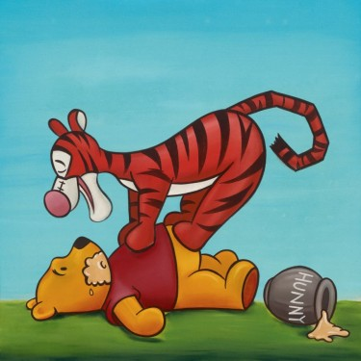
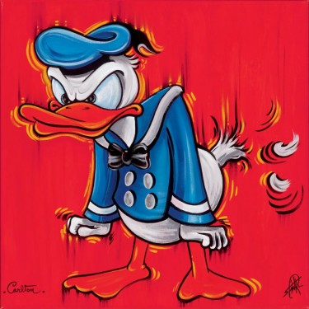
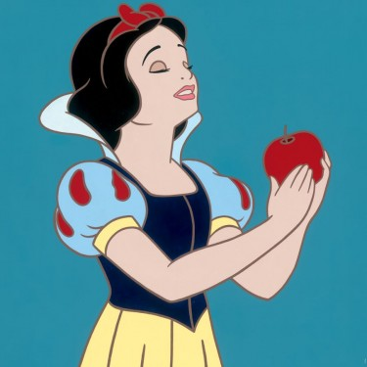
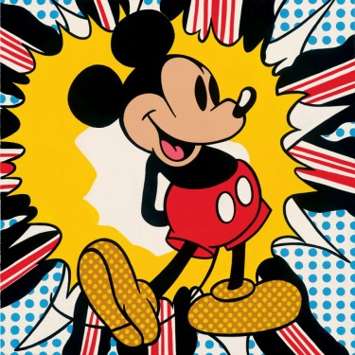
Beef or Chicken Burger
served with chips and beans
Cheese Omelette
Beef Lasagne
served with garlic bread
Fish Fingers
served with chips and peas
Chicken Nuggets
served with chips and beans
Sausage
served with mash and veg
Mini Steak
served with chips and veg
£5.50
DESSERTS
Selection of Ice-creams and other deserts.
Please ask to see dessert menu.

Bar Snacks
Nachos £4.75
Our Chips £2.50
Cheesy Chips £3
Onion Rings £3.50
Chicken Nuggets £4.50
Jacket Potato – Cheese & Beans or
Pesto Chicken £6.50
8” Sausage Roll £2.50
Garlic Bread £2.75
Garlic Bread with Cheese £3.25
Sausage, Bacon & Egg Bap £4.50
Scampi & Chips £6

